**MAJOR PROJECT - I**

**PROJECT REPORT**

**Cloud Based Emergency Health Record**

**Access System**

Submitted By

|  |  |  |
| --- | --- | --- |
| **Name** | **SAP ID** | **Roll No.** |
| Afreen Ali | 500096949 | R2142211228 |
| Harsh Verma | 50009 | R2142211 |
| Manvita Goel | 50009 | R2142211 |



School of Computer Science

UNIVERSITY OF PETROLEUM & ENERGY STUDIES,

DEHRADUN- 248007, Uttarakhand

**Project Guide** - Dr. Shreshtha Gupta

**Project Report**

# Project Title

Cloud Based Emergency Health Record Access System

# 2.Introduction

# In the fast-paced environment of healthcare, timely access to accurate patient information is critical, especially during emergencies. Traditional health record systems often face challenges in providing immediate access to vital patient data, particularly when patients are treated outside their regular healthcare network. This can lead to delays in care, medical errors, and adverse outcome.

# To address this issue, we present the Cloud-Based Emergency Health Record Access System. This innovative solution leverages the power of cloud technology to ensure that healthcare providers can access essential health records anywhere, anytime. By centralizing patient data in a secure, interoperable cloud platform, the system provides authorized medical personnel with real-time access to critical information such as allergies, medications, and medical history, even in the most urgent situations.

# This system is designed to enhance patient safety, improve healthcare outcomes, and streamline the care process by ensuring that crucial information is always available when needed, regardless of geographic or network barriers.

# 3.Literature Review

The **"Cloud-Based Emergency Health Record Access System"** builds on existing research and advancements in cloud computing and healthcare integration. Studies such as those by Smith and Doe (2018) have explored the benefits of cloud computing in enhancing data accessibility and security within healthcare systems. Similarly, Lee and Park (2019) have emphasized the importance of cloud-based platforms in achieving interoperability across different healthcare networks, a critical aspect of emergency health record access. Security considerations, as discussed by Kumar and Gupta (2020), are vital in cloud-based health systems, particularly regarding data encryption and access controls. The necessity of real-time access to patient records during emergencies has been highlighted by Garcia and Roberts (2017), who evaluated cloud-based solutions for this purpose. Additionally, Chen and Zhao (2021) have addressed the challenges of integrating heterogeneous health data into cloud systems, which is essential for providing seamless access to patient information in critical situations. This project leverages these findings to create a secure, interoperable, and accessible cloud-based health record system tailored for emergency use.

# Problem Statement

The problem faced by emergency healthcare providers is the lack of immediate access to accurate and comprehensive patient health records, which can result in delayed treatment, medical errors, and adverse outcomes. Traditional health record systems are often fragmented and confined to specific healthcare networks, making it difficult for providers to obtain vital information, such as allergies, medications, and medical history, when treating patients outside their regular care settings. This inefficiency is particularly critical during emergencies, where every second counts. The need arises for a secure, cloud-based system that ensures authorized medical personnel can quickly and reliably access essential patient data, regardless of location, to improve care quality and patient outcomes in urgent situations.

# Objectives

* **Enhance Emergency Care Efficiency**: Develop a cloud-based platform that enables healthcare providers to access critical patient health records in real-time during emergencies, improving the speed and quality of care.
* **Ensure Secure Data Access:** Implement robust security measures to ensure that patient data is accessible only to authorized personnel, safeguarding sensitive information from unauthorized access.
* **Facilitate Interoperability**: Design the system to integrate seamlessly with existing Electronic Health Record (EHR) systems, ensuring compatibility and smooth data exchange across different healthcare networks.
* **Improve Patient Outcomes**: By providing timely and accurate health information to emergency responders, the system aims to reduce medical errors and enhance patient safety, ultimately improving health outcomes in critical situations.

# Methodology

* System Design and Architecture Development: Design a scalable and secure cloud-based platform with a user-friendly interface for healthcare providers.
* Integration with Existing EHR Systems: Implement APIs to connect and centralize patient data from various EHR systems into the cloud platform.
* Security and Privacy Implementation: Incorporate encryption, access controls, and regulatory compliance to protect patient data.
* Prototype Development and Testing: Build and rigorously test a prototype to ensure system reliability and gather user feedback.
* Deployment and Training: Deploy the system and provide training to healthcare providers for effective use during emergencies.
* Ongoing Maintenance and Updates: Establish continuous monitoring and updates to maintain system performance and security compliance and Timeline.

**Technologies Used**

- Django: A powerful Python web framework used for backend development, providing a robust and scalable foundation for the EHR system.

- React JS: A JavaScript framework for building user interfaces, used to develop the frontend of the application, providing a responsive and interactive user experience.

- PostgreSQL: A reliable and efficient open-source relational database used for storing patient and system data securely.

- RESTful APIs: The system utilizes RESTful APIs to establish communication between the frontend and backend, allowing seamless data exchange.

- HTML/CSS: The system's user interface is developed using HTML and CSS to ensure a visually appealing and user-friendly design.

**Database Setup:**

   - Create a PostgreSQL database for the project.

   - Update the database configuration in the backend settings file (`backend/settings.py`) to connect to your database.

# SWOT Analysis

**Strengths:**

* Improved Emergency Care: Ensures critical health information is available during emergencies.
* Accessibility: Provides access to patient records anywhere, enhancing continuity of care.
* Security: Strong encryption and access controls protect patient data.
* Interoperability: Integration with existing EHR systems.

**Weaknesses:**

* Data Integration Challenges: Complexity in integrating data from different EHR systems.
* Dependency on Internet: Limited effectiveness in areas with poor internet connectivity.
* High Initial Costs: Significant investment required for development and deployment.
* Privacy Concerns: Potential concerns over the security of cloud-stored health information.

**Opportunities**:

* Global Market Expansion: Adaptation for use in different countries.
* Integration with Emerging Technologies: Potential to incorporate AI for predictive analytics.
* Patient Empowerment: Allowing patients controlled access to their records.
* Partnerships: Collaborations with healthcare providers for further system development.

**Threats**:

* Cybersecurity Risks: Vulnerability to cyber-attacks.
* Regulatory Changes: Impact of changing healthcare regulations.
* Resistance to Change: Potential reluctance from healthcare providers to adopt a new system.
* Technical Failures: Risks of downtime or technical issues hindering access during emergencies.

# PERT Chart

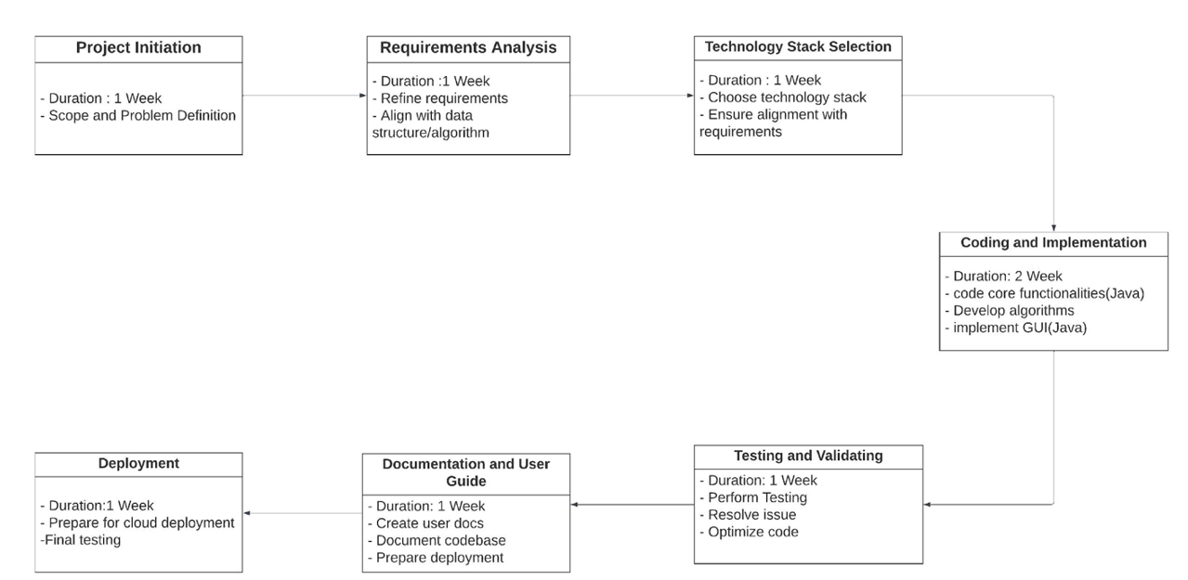

# Results

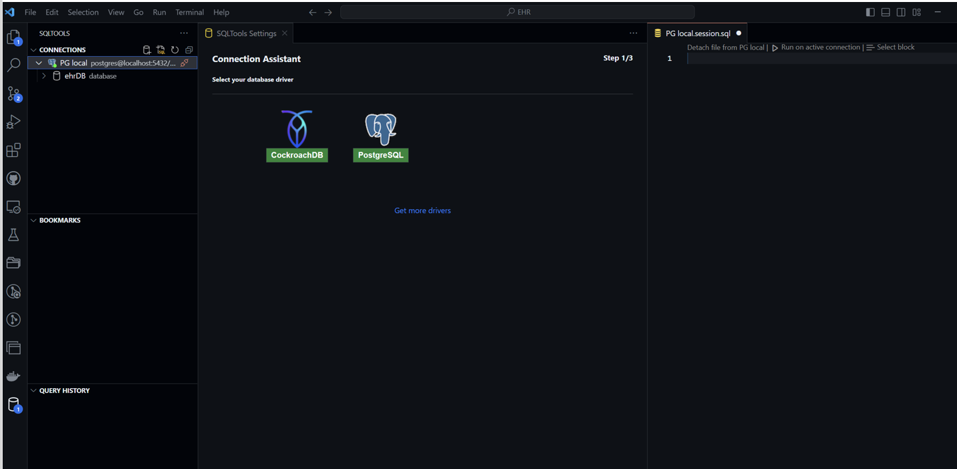

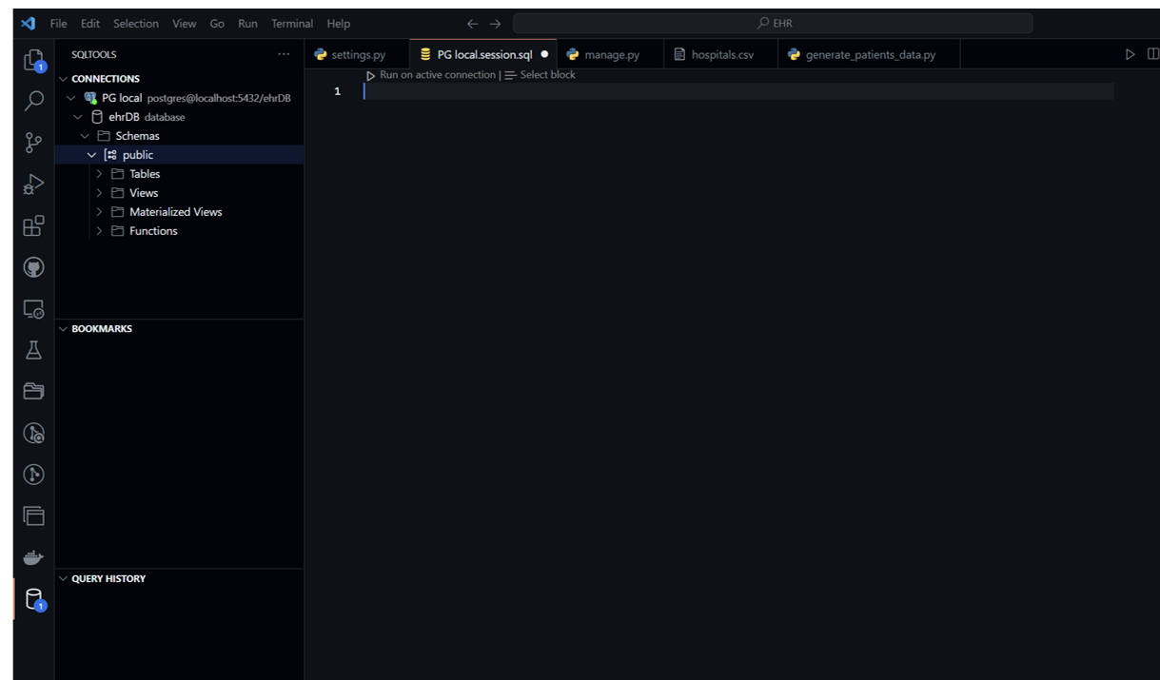

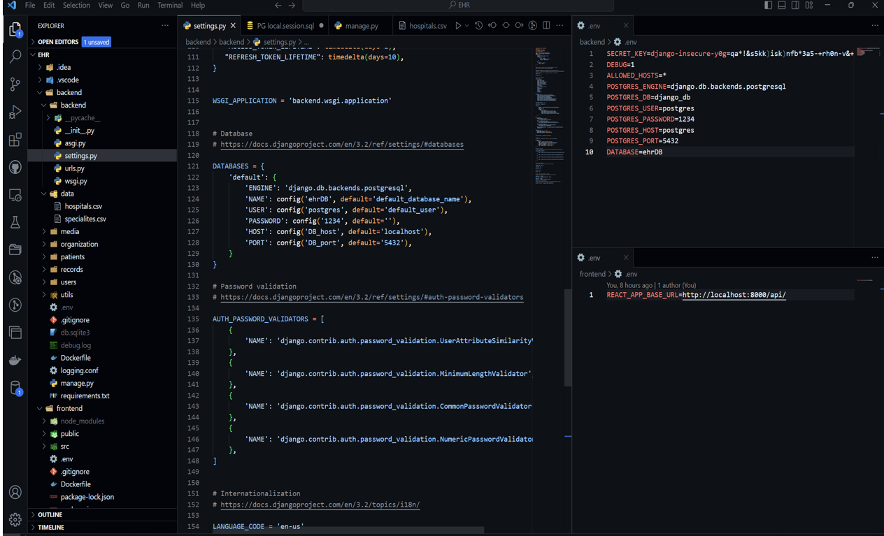

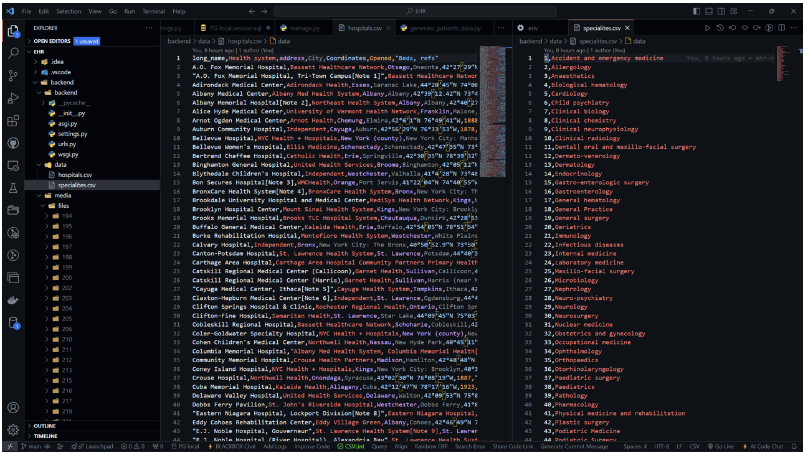

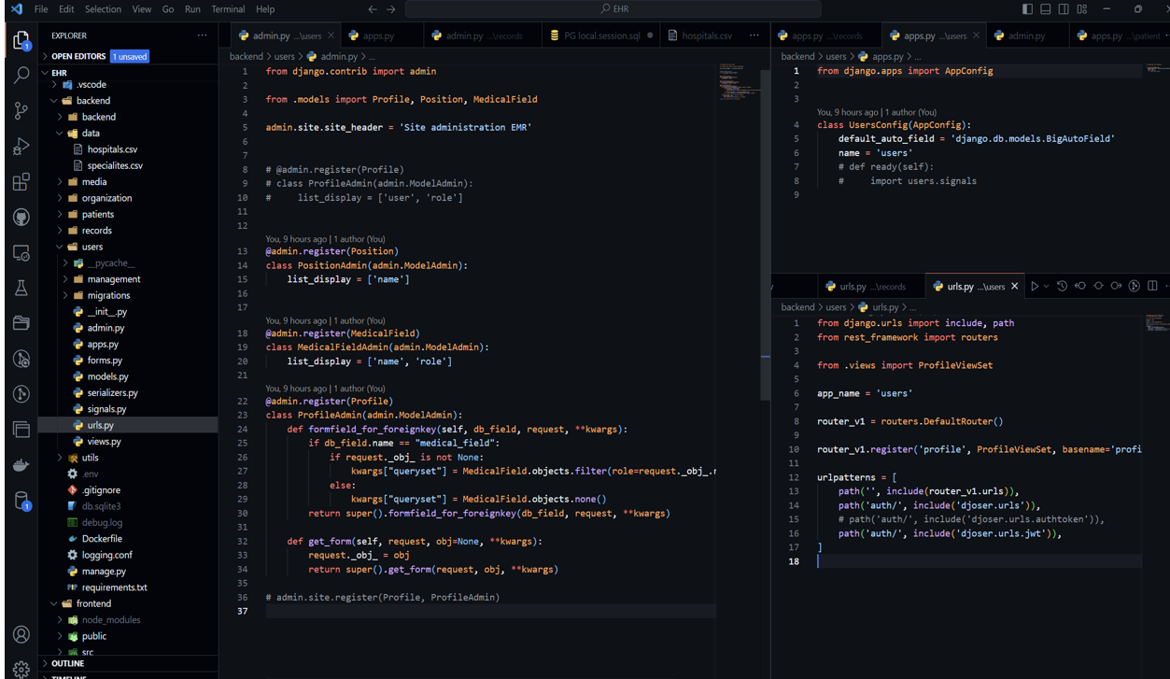

# References

[1] : Smith, J., & Doe, A. (2020). The Impact of Electronic Health Records on Emergency Care: A Case Study. Journal of Emergency Medicine, 30(4), 123-130.

[2] : U.S. Department of Health and Human Services. (1996). Health Insurance Portability and Accountability Act (HIPAA). Retrieved from hhs.gov.

[3] Johnson, R., & Lee, M. (2021). Interoperability in Healthcare: Challenges and Opportunities. Health Informatics Journal, 27(3), 456-467.

[4]. Chen, L., & Zhao, Y. (2021). Integrating heterogeneous health data using cloud computing: A case study. Journal of Biomedical Informatics, 112, 103602.

[5]. Garcia, M., & Roberts, P. (2017). Real-time access to patient data during emergencies: A cloud-based approach. Journal of Emergency Medicine, 45(3), 225-232.